Masthead
For the masthead (aka the brand logo) I wanted a serif font as that’s the convention for most luxury magazines. I’d prefer to go with custom fonts as it’d make my brand name stand out more, but I’d be fine using a default one as well since the serif fonts that luxury magazines use don’t really stand out that much and are quite similar to each other.

Afro Elite
[Default] Bell MT
This is an example of what I’m looking for, a basic serif font. I think it works with being a masthead font but I wanted to look at more examples before I choose one.
Afro Elite
[Default] Bodoni MT
This is very similar to the previous font but I feel like it has a bit more emphasis due to it being slightly more bold. If I really wanted to I could use them both together in the logo to make it stand out a bit more.
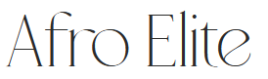
[Befont] Mallong
I like how this font is elegant while still being very different from the previous ones, even though it is different I feel like it could still fit.
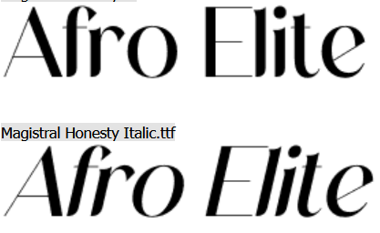
[Dafont] Magistral Honesty
This font is similar to the basic ones while still being different. I like both versions of the fonts as well and how it gives me more variety to work with. Despite it being a bit more bold than I wanted, I might use this one as I like its overall aesthetic.
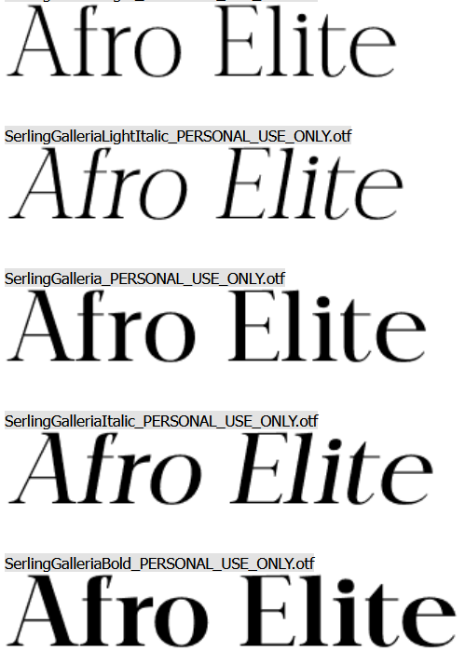
[Dafont] Serling Galleria
This font feels very similar to fonts luxury magazines use for their logos, I’ll likely be using this one as I feel like it has the perfect balance of everything I wanted (multiple options, serif and it feels like it has “the right amount” of boldness).
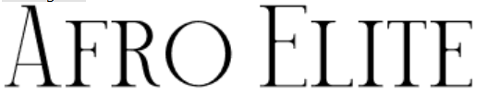
[Dafont] Mechago
I didn’t want to go with any fonts that were too condensed, but I really like how everything is styled in uppercase but you can still tell which letters are actually in uppercase. It also has a slightly different feel to the other fonts which I like.
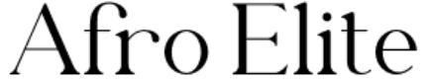
[Dafont] Matcha
I like how this font is skinnier in some places and I feel like the way the ‘r’ is stylised gives it a bit more character.

Headings
For my headings I wasn’t as confident in what I wanted to go for, I knew I should have something that matched my masthead though (or at least something that’s similar to it). I feel like I could use any of the fonts above for this if I really wanted, but I wanted to look at a few more that could work.

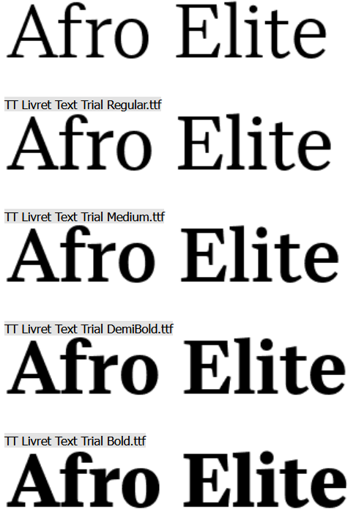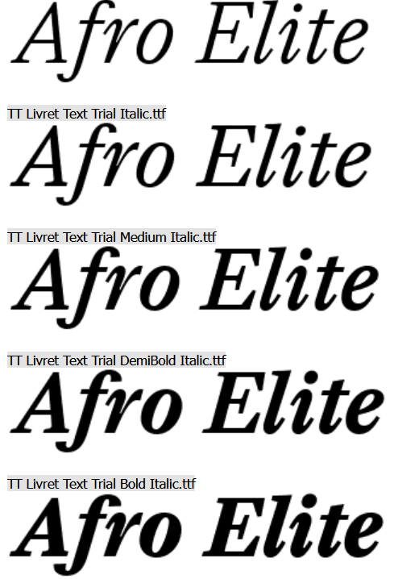
[Dafont] TT Livret Text
This font feels like it could work as a header, especially since it gives me a lot of options to work with. It’s similar enough to most of the options I picked for my masthead as well.
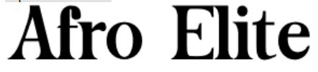
[Dafont] Captain Meredith
I wanted to branch out from fonts that all looked too similar to each other. I feel like this works as a subtle but noticeable change from the rest as it’s serif is shaped differently to the others, starting off flat and then curving out at the bottom.
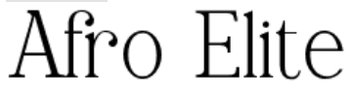
[Dafont] Balmoon
I feel like this font could work with Mallong or Matcha. The main reason I picked out this font is because I liked how the ‘r’ was styled in it.
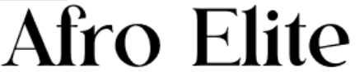
[Dafont] Hanoble
I like how the font is bold, even if it doesn’t stand out much against all the other fonts I’ve already picked out. I also like how the lowercase ‘e’ is stylised with a slant.

Subheadings
For the subheadings I knew I wanted something italic, but I didn’t want to go with a handwritten font since those are much harder to read. I’ll likely be using TT Livret Text or possibly Serling Galleria for subheadings as they’re the clearest example of what I want (very similar to heading/masthead font choices), but looking at other alternatives was also a good idea.

Afro Elite & Afro Elite
[Default] Bell MT & Bodoni MT
I felt like these two fonts could work for subheadings as they’re extremely simple and easy to read while also fitting with the fonts used in a luxury magazine. The only downside is there’s no italic versions of them available, but this isn’t a problem as I know you can do makeshift italics in InDesign.
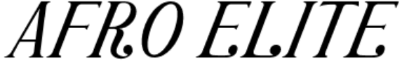
[Dafont] Portalica
I like how this font is already in italics, but I don’t know how I feel about how exaggerated it is (the dots at the bottom). It’s also automatically in uppercase no matter what which isn’t really ideal.
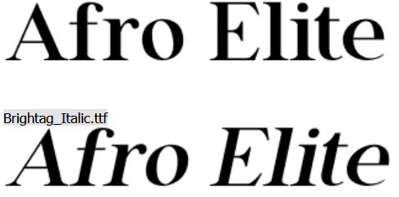
[Default] Brightag
This font feels perfect for what I want the subheadings to be, so I’ll likely be choosing this one if I don’t choose any I’ve already previously mentioned.

Text
I’m sticking with default fonts only as they’re the most basic and simplest to read. I remember one of the criticisms I got for my previous magazine was that choosing a bold font for the main body of text wasn’t a good idea, so I won’t be picking any of those.

Text, Afro Elite, Words
[Default] Tahoma
Text, Afro Elite, Words
[Default] Arial
Text, Afro Elite, Words
[Default] Calibri
Text, Afro Elite, Words
[Default] Bahnschrift Light

