I knew what I was going to do for FMP since the end of last FMP. The original idea of Afro Elite was always a printed magazine focused on Black women, but it was originally focused on the locals in Luton. After I did my pitch I was given feedback to make the magazine global rather than focus only on locals which I did, mainly as there’s not too much content to write about if I made it about Luton only. I’ve also done a print magazine for my previous FMP as I like designing them, but since this is my last FMP I needed to challenge myself in some way still. One of the main reasons I chose to do a printed magazine again (other than me liking to make them) is because I’m ultimately not happy with how my previous FMP is designed. It makes sense for the target audience it was for and I probably wouldn’t change much about it if I were to make it again, but it wasn’t a design I’m very keen on as looking back on it I feel that it looks amateur. I wanted to create a more professionally designed magazine and the feedback I got from my tutor during my initial research said I should make Afro Elite a high-end luxury magazine, which would be difficult but I knew it was possible for me to do. So Afro Elite originally started out as a magazine focused on locality and then turned into a high-end luxury magazine, but the core principle of what it’s about always stayed the same. The reason why I decided to make my magazine focused on Black women will be talked about at the end of the evaluation.
The name of the brand was mainly inspired by Elite Traveller, I chose Afro Elite since it was punchy and memorable unlike the temporary name I went with in my pitch – Adroitly. It’s also mostly clear who the magazine is for, the magazine is clearly for Black people even if it’s not clear the magazine is mainly focused on women specifically by the name alone.
My initial research mainly focused on if there would be an audience for this. Magazines for and about Black women are obviously already a thing (a few examples of them are Essence, Munaluchi Bride, Melan and Black Beauty and Hair). Majority of the ones I found had both physical and digital releases for their magazines so my idea for a magazine wasn’t too out there.
I also looked at Bute Street Film Festival for any films focused on Black women and there was a film called Pick It that I could’ve featured, I also found out that multiple Black women were having talks during the festival as well. Originally I was planning to interview Adeyinka Akinrinade for the magazine as she was one of the Black women having a talk at the festival, but I eventually decided I’d interview Akua Gyamfi and Gabrielle Smith instead since they felt like a better fit for my magazine later on (mainly because my target audience later changed to be roughly the same age they are and since they’re both part of the same panel, so it’d be easier to reach them). Looking back on it I’m not sure why I didn’t consider interviewing all three of them.
The last thing I quickly skimmed through were what the articles in luxury magazines are about and I found that majority of them talk about very similar topics (fashion/beauty, travel, culture & celebrities are consistent topics throughout every luxury magazine I looked at for all of my research).
After my initial research, I did my research list and my project proposal. My project proposal is a little outdated. As mentioned before the core concept of the magazine was always there, but a few changes happened during production and even post-production that the project proposal doesn’t reflect. I was originally planning to 16-18 pages but during the production I had to add more pages, it eventually became 24 pages for different reasons (Tasha’s interview being a little too long, the printers I was working with only printing in multiples of 4 pages and me making the products page a double spread instead of a single page like I was originally planning).
The target audience in the project proposal is also wrong as I changed it due to pitch feedback. I was originally focusing on a more younger target audience for my primary audience as part of the magazine was also meant to inspire young Black women climbing up the career ladder, but after the feedback I got I realised they likely wouldn’t be able to afford a luxury magazine like this in the first place. I ended up swapping the primary target audience and the secondary target audience around for the most part in terms of ages (my primary audience were now 26-30 year olds, secondary was 31-40 year olds and tertiary was 20-25 year olds). My design brief is a much better reflection of what the magazine ended up being rather than the project proposal, even if the pages are still wrong (on the design brief it said it was 18 pages).
I started on my research afterwards. My research list consisted of three main topics: the magazine’s brand, other people and the articles. While making my research list I considered last year’s research list for my FMP, I didn’t want to do research into things that I already did previously such as how to make effective headlines.
For the magazine brand:
- How will the magazine be designed?
- What branding will the magazine have?
- What will the magazines brand be?
- What will the advertisements in the magazine be?
The magazine’s design was mainly focused on me looking at other luxury magazines and doing research on the fundamentals of layout design. At the time I knew I didn’t like the design of my previous FMP’s magazine much and I wanted to improve on it. I tried to do this for my previous specialised unit but ultimately felt that I didn’t learn much about magazine design specifically, mainly because I didn’t do much research on it and the fundamentals. I set to do just that while researching this time.
“What branding will the magazine have?” and “What will the magazines brand be?” seem like the same question on paper. When looking at what branding the magazine will have, I looked at the social media other luxury magazines had and what they promote on it so that I’d know what I should do for my magazine. The magazines brand focuses on the actual brand itself such as colours, fonts and logos that my brand should be identified with. The advertisements fit into this as well and is self-explanatory.
For other people who’ll either help me with the magazine or be featured in it:
- Who will be the women featured in the magazine?
- Who will you interview for the magazine?
- Who will you get industry feedback from?
- Who will you get audience feedback from?
The first two questions also seem a bit similar, but I planned on featuring other women in the magazine other than the people who would be interviewed. I knew I wanted to feature a celebrity in one of my articles as that was a code & convention in luxury magazines. At the time I also did research on a historical figure to feature in the magazine as there was a section on Black History Month on TIME (one of the magazines I was taking inspiration from at the time), but I eventually scrapped this idea since I ultimately felt like it didn’t fit with a luxury magazine.
For the second question I mainly knew the answer already, I bought tickets to attend Bute Street Film Festival to interview Akua Gyamfi and Gabrielle A. Smith during research and went to the festival during Easter break (pre-production). I wasn’t able to interview them there since the festival was very loud, I agreed with them both that I’d conduct the interview through email instead. I was a bit worried about doing this since it wasn’t guaranteed I’d get responses even though they knew I was emailing them, but I planned for this in my contingency plan regardless (I’d send reminder emails if I didn’t get the responses on time and if that still doesn’t work then I’d have to turn their interviews into articles, which wasn’t ideal). They responded to my questions via email so it wasn’t an issue.
I was able to interview Tasha Case due to my tutor recommending me to her earlier. I did an interview with her about VERU during research which is where she works. Admittedly it was the least useful research I conducted as I didn’t use the information I got from the interview, but it served as an introduction to Tasha as she was the only person I was able to interview face to face and I was planning to do a photoshoot with her.
I hoped to interview Nima Elbagir (one of the people who hosted a talk during the British Film Institute trip my class went to) for the magazine, but I couldn’t contact her directly and never got a response back from the CNN email I found.
I got industry feedback during all stages of production and even during the research stage, which was what I planned for. I got feedback from copywriters as I was a bit worried for my writing skills when it came to luxury magazines, especially since they’re usually very descriptive which is something I’ve always wanted to be good at but never was. The feedback I got from the copywriters was extremely beneficial as they told me about some things I wouldn’t have known or considered (like assuming the readers already know what you do on a yacht for example, so I shouldn’t explain it to them but I should rather focus on the experience of being there itself). During production and post-production I’ve gotten feedback from magazine designers, but that’s for later on.
I was actually planning to get audience feedback during production as well, but I had a difficult time finding a focus group. I was originally in a Facebook group that was for Black women interested in luxury but it was private. I had to send an invite and in that I detailed that I’m mainly joining to get feedback for my magazine as the people in the group are my primary target audience. My invite was accepted, but then later on I made a post about my magazine and I was kicked out. There were a few other Facebook groups for the same purpose, but I got rejected from all of them. I ultimately decided that getting feedback during production wouldn’t have helped me much anyway (I was already getting feedback from magazine designers for production at this point) and moved it for post-production.
I think if I could change anything from my research stage, it’d be to get audience feedback during this time instead. Audience feedback during research is the best option for it since its very early into the project and I don’t have to make major changes to anything yet, while if I did it in pre-production or production there are certain things about the magazine that I wouldn’t be able to change or it’d at least be a hassle to (the article topics are a notable example).
For the articles:
- What tone will the articles be written in?
- What will the articles be about? (balance of light-hearted & serious topics)
Finally I did research for the articles. I vaguely knew about the tone I wanted for them but I wanted to make sure I knew how most luxury magazines were written. I also wanted to know what luxury magazines focus on specifically, so I did more research into that instead of only going with what I knew from my initial research. I did the actual research for most of the articles during pre-production as I didn’t want to focus too much on the articles yet, especially since I wasn’t completely sure what I wanted every article to be about at the time.
Looking at other luxury magazines was the most important research I did since I have little to no knowledge about them. It helped with the branding especially since I was able to see what colours, fonts and logos luxury magazines typically use. It also helped with article topics and how I should write them as I was able to compare what most luxury magazines talk about and how they do so. The advice I got from the copywriters was useful as well for reasons I’ve already mentioned prior.
I mentioned the first interview I did with Tasha Case not being used, but technically the least effective research would’ve been the research I did on Harriet Tubman as I eventually changed my mind on including her in the magazine. I had doubts as I was doing research about her, but I continued with it as I didn’t have any ideas on what to replace that article with yet.
Ultimately I think I did how I usually do with research. Ever since I did the game show unit I feel like I’ve plateaued with my research skills, which is fine. Since this is the last evaluation I’ll write, I’ll talk about my improvement from when I first joined this course. At the beginning I had a hard time understanding how I was meant to format anything (which is to be expected as I was previously doing my GCSE’s, unlike most of my class I never did Level 2 Media) and barely wrote much for my research. At the time I didn’t like having to write down everything I learnt from a source even if I ultimately understood why I had to as I wasn’t that great at articulating. This quickly changed in the next unit as I started getting used to what was expected from me and between Genre Changing Trailer and Game Show I rapidly improved with researching. I used multiple sources from different mediums and wrote more commentary about what I learnt from them, making them a lot longer. I eventually ended up liking research as I liked starting out small with them and watching them become considerably longer (not that I purposely made them so, it was just a consequence of having more to write about).
But back to my research for this unit, there was more I could’ve done especially with my research into the fundamentals of magazine design. As part of that research, one of the videos I watched for it was the first part of a series of guides about magazine design. I was planning to watch more of it as I went along with production, but I never did. The video itself did help me a bit with designing my magazine (mainly by teaching me the fundamentals) so it was a missed opportunity to not continue watching it. I talked about how I could’ve gotten audience feedback at this stage already, but looking back on it I think I really should’ve done primary research pertaining to my audience since the only audience feedback I’ve gotten from this project is at post-production. The feedback I got during post-production wasn’t very substantial, but I still should’ve done it as I would’ve had concrete evidence on what article topics my audience would’ve been interested in for example.
After the research, I had to do a pitch. The pitch went a lot smoother than I thought it would. I got valuable feedback from the pitch and made many fundamental changes for it such as changing the name and the target audience. Since I changed the target audience, it changed what I wanted to do for the articles I hadn’t done research on yet. In a way it saved me a bit of time as I was originally planning on having an article with CV / interview advice, which would no longer be relevant to the new target audience I’ve chosen.
I made a contingency plan for everything that could go wrong during the rest of production. I made sure to make it as thorough as I could as it’s meant to act as a guide for me just in case something goes wrong and, considering that this is FMP, I knew issues were likely to appear. The first (and main) issue was about sourcing people for the focus group during production that I later scrapped, so I’ll skip over it. None of the issues in the plan came up so I didn’t end up using much (the only major problem that happened was a scheduling issue with Tasha’s second interview & photoshoot) but it’s still important just in case something did happen.
At the time of making the plan I knew what I would’ve done if I wasn’t able to meet Tasha face to face for the photoshoot, but I didn’t detail what I’d do if she couldn’t make it for the interview (likely since I was planning to do both together – the photoshoot first and then the interview afterwards). I would’ve done the interview through email instead if Tasha wasn’t able to do the interview face to face, we already had each other’s emails from the first interview.
I also added a section about time management in the contingency plan, but it only covered pre-production. Considering the rest of the plan covers all aspects of issues that could’ve happened during each production stage, it likely would’ve been beneficial for me to plan more for time management. I understand that planning so far ahead would’ve been a bit difficult, but it was possible as I had a schedule from my design brief and another given by my tutor at the beginning of the unit.
During Easter break, I had to do the majority of pre-production as I’d only get a week back in college to finish it. In last year’s FMP working during the Easter break was a significant struggle, half because of how I had to work during that time and the other half due to procrastination that tends to happen whenever I take a break. I didn’t have a laptop and could only work on my phone last time which was a nightmare I’m glad I didn’t have to repeat, but I mentioned still being worried about how I’d work during the break in Daily Diary 30/03. Knowing that my work would’ve been looked at during the Easter break did motivate me to do most of it during the break although my second week during break was much better than my first.
I did research for my articles and most of the documents I chose to do for pre-production. Looking back on it, I should’ve done an image justification instead of only a font one.
I had to go to a film festival during pre-production, but aside from that the most enjoyable aspect of pre-production was doing the copywriting framework and the mock-up. I liked writing the framework since it was something extra I was doing and it paid off a lot for me as I used it a lot while I wrote my articles. I also liked doing the mock-up for the most part since it’s like a small portion where I’m able to do what I like doing most, design a magazine. Writing the articles was the most challenging part though, as mentioned in my daily diaries I’m not good at writing descriptively like luxury magazines do. I’ve always liked descriptive writing (or called purple prose, which is what I’ve known it as) but despite my attempts I’ve never been that good at it. I think the articles are written fine enough for what I was going for, but I remember after finishing them I still wished I could’ve done better with the descriptions used in the magazine (specifically in The Top 5 Beauty Products
You Need for Spring & Taking a Maldive(s) with The Ritz-Carlton).
Usually I’m not meant to do research during pre-production, but I purposely made myself research articles during this time since I didn’t want to focus on them too much during research. This is mainly because I didn’t think I had enough time to dedicate all of that to just researching for articles I wasn’t sure I was going to keep (like what happened with Harriet Tubman), but I also didn’t have many ideas for what I wanted my articles to be about yet during the first stage of research.
I decided what articles I wanted in the magazine through my previous research into magazines. I wanted to include articles such as the Top 5 Beauty Products, The Ritz-Carlton Maldives and the article on Ruth E. Carter & The Oscars (this article was originally going to be the article about celebrities, but after doing more research it turned into an article about Ruth E. Carter being the first Black woman to win two Oscars). This was due to articles on beauty/fashion, travel and celebrities being a staple for luxury magazines. I always knew I wanted an article on hairstyles since I first made my mind map at the start of FMP as hair has always been an extremely important part of Black culture and still is today, it also fits in as a beauty article.
The How To Manage your Work / Life Balance article was added before I changed the target audience, but I kept it since I still felt it was general enough to work. The original idea was that since the magazine is focused on young Black women who are still climbing the social ladder, it’d make sense for one of the articles to essentially be a reminder not to burn themselves out. At the end of the day it’s still advice anyone could use though which is why I kept it.
I added a page dedicated to Black owned businesses since I felt like it’d fit with the magazine brand. The Afro Elite brand is about supporting and promoting Black women, in the brand’s hypothetical social medias it’d focus on nurturing a community of Black women who support each other. The article fits in with the brand since that’s exactly what it is. I added a small section of text at the beginning of the article that implies the brands featured on that page were submitted through the brand’s email. I also added something Tasha said in her interview at the end of it, which is something I never knew if I liked or not.
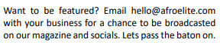
— Afro Elite (final magazine / Supporting Black-owned Businesses on page 16)
I wrote a copywriting framework before my articles. For some context, one of the copywriters I contacted linked me to their Instagram account where they post tips for luxury copywriting. One of their tips was to have a copywriting framework so that I’d know what my audience wants & needs and how I’d cater to that. The framework didn’t have a set format for me to work from since it’s not part of the regular pre-production, so I wrote it catered to what would be best for me (the beginning portion where I detail my target audience is in full sentences, but the rest of the document is in a note format).
It actually did help quite a bit for when it came to writing my articles, specifically when it came to writing about more specific details about the audience like the mosaic group and the audience profiles. It gave me a chance to detail why they specifically would like the magazine and what they’d be able to get out of it, so I was able to lean into that a bit more. For example I knew that people in the A03 group might be burnt out so I added a few relaxing descriptions in the magazine so they’d be able to relax more. I knew I had the Work-life balance article to cater to them already, but I didn’t want that to be the only way I did.
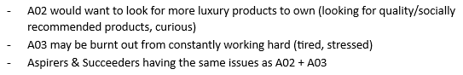
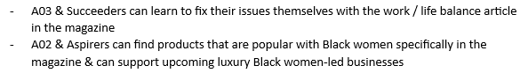
— Copywriting Framework
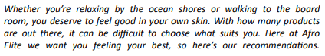
— Afro Elite (final magazine / The Top 5 Beauty Products You Need for Spring on page 5)
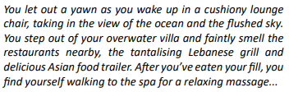
— Afro Elite (final magazine / Taking a Maldive(s) with The Ritz-Carlton on page 11)
I wrote two drafts of my articles before production, but the final version of two of the articles (The 2023 Proves that Times are Changing & How To Manage your Work / Life Balance) actually happened during production since no one proof read them for me beforehand. In the end I’m glad they were proof-read since I feel like both articles, the Oscars one especially, were improved by the edits I made. The feedback I got for the work-life balance article was only about making small tweaks at the end as certain words repeated too much, but for the Oscars I added a section on what the changes could mean for the future which I feel elevates the article and makes it better (now it actually says something and isn’t me just throwing facts at you).
The main skill I learned during pre-production was, unsurprisingly, the importance of planning. Since I had to choose what pre-production documents I had to do for this unit, I felt like I understood everything I was doing a lot more than usual. Every single document I did during pre-production had a purpose like the storyboard (was created so I knew what I wanted for the photoshoot) to the font justification (was made so that I knew what fonts I’d be using for the magazine). Even when doing the mock-up I realised how important planning was. During last year’s FMP I found it quite stressful to design the magazine, mainly because I didn’t know much about layout design and felt frustrated with placing elements. Now that I was treating the mock up like what it was intended for instead of immediately jumping into designing the magazine, I felt much better while designing this year’s magazine even if I didn’t stick with most of the designs in my original mock up.
During production there was only one major issue that happened, but it was fortunately resolved quickly. I planned to have the second interview with Tasha and her photoshoot on the 26th of April, however she emailed me saying she wouldn’t be able to make it about an hour before it would’ve happened. This happening wasn’t that surprising to me as we had a few issues doing the first interview about VERU (at first it was about finding a platform to conduct the interview and then something important came up that Tasha had to deal with). I don’t blame her as the nature of her job means problems like this can happen sporadically. I emailed her back with another time we could do the second interview & photoshoot and she agreed a few minutes later. We were able to conduct it on Friday with no issues. This didn’t affect my schedule too much since I was planning to go to college that day regardless. I planned for this in the contingency contract and while the solution wasn’t the exact same, it was very similar to what I originally envisioned doing (in the contingency plan it says that I would’ve moved it to a day in production since I was originally planning to do the interview & photoshoot during the last week of pre-production). Since the studio was already set up for the photoshoot on the 26th, I decided to do my own photos on that day since I needed them for the magazine.
Another more minor problem also happened during production, despite getting feedback from two different magazine designers there was a point where I was only getting feedback from one or the other. I was confused why this was happening at first but at the time brushed it off since I was still getting feedback from one of them at least. It wasn’t until the second week of production that I sent a reminder email to Paul (the magazine designer I still hadn’t gotten feedback from yet) that I was told what happened. He said he didn’t receive the previous emails I sent him since my attachments (the PDF’s I was sending of my magazine drafts) were too big. I then used WeTransfer to send him the files from then on. I’m unsure if this was something that could’ve been avoided as when I sent my mock-up to him it was attached to the email and he received it just fine, so I wouldn’t have suspected anything. I think I definitely should’ve sent a reminder email to him earlier though as it would’ve given me more time for me to work with any feedback he gave me.
Overall these problems were able to be solved through communication. I often find myself having a hard time sending emails and contacting people, which is something I feel like I’ve pushed through and gotten better at through solving these issues. I feel like there’s something else that could count as a problem too, but that’s more of a mistake I made rather than a problem that I could’ve solved and I’ll talk about it during post-production.
Now onto the final product. I actually do like it a lot and how it came out (way more than vision, my previous FMP). I naturally have very high standards for myself and I feel like I’ve met those expectations with Afro Elite. As mentioned before, I had a lot more fun when designing this magazine than with vision mainly due to me making a proper mock-up and understanding layout design more. I had never read a high-end luxury magazine prior to this but after doing my research and designing the magazine, I’m confident that I was able to emulate their style.
While designing the magazine I was looking at Billions Luxury Magazine as a reference. For example, I decided to add lines as a design choice for the entirety of my magazine because I liked how the lines on Billions’ table of contents page looked. I also based my table of contents page similarly to the one below with pictures for the most important articles in the magazine, with the page numbers inside the image.
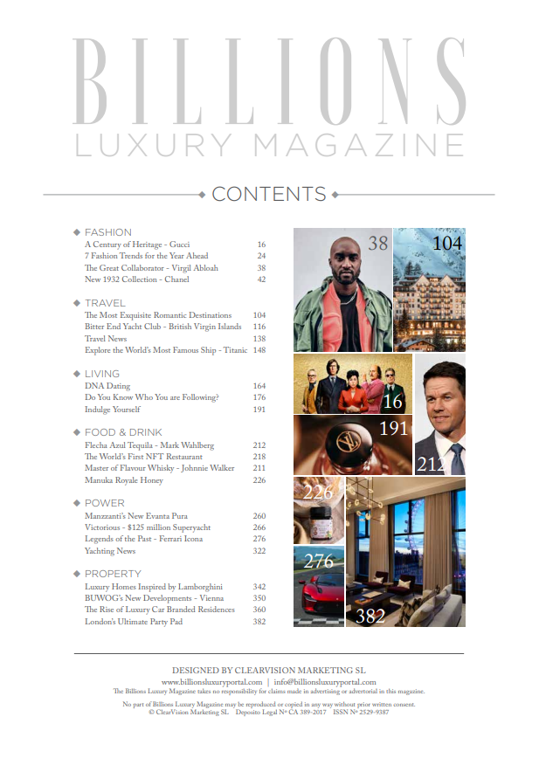
— Billions Luxury Magazine (Table of Contents on page 9)
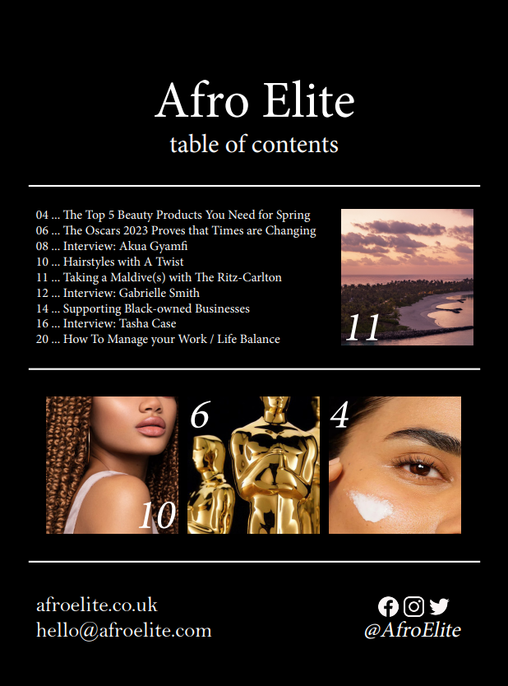
— Afro Elite (final magazine / Table of Contents on page 3)
The Afro Elite advert in the magazine was also heavily inspired by the advert for Billions in their own magazine. I added a tagline like in the Billions advert (‘New Name, Same Luxury Content’ and ‘Fashion, beauty, lifestyle and travel for Black women by Black women’) and also added the ‘Available on ___’ buttons and made sure they were the same as Billions, as this would mean the digital version of my magazine would match with what other luxury magazines are typically on.
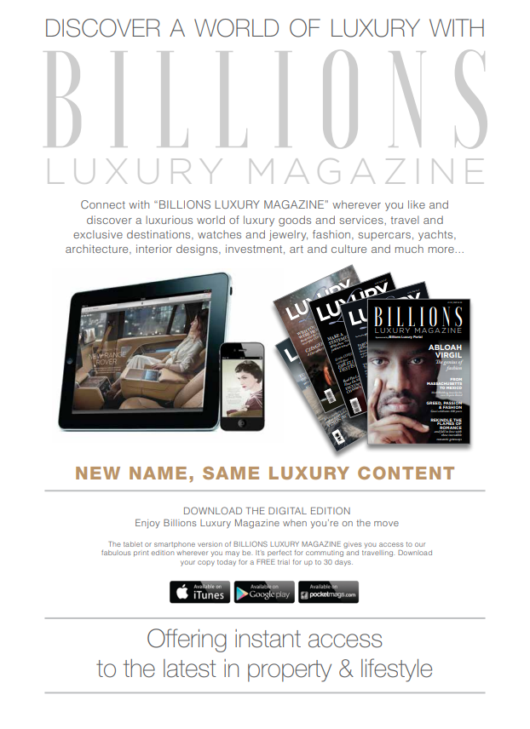
— Billions Luxury Magazine (Billions advert on page 40)
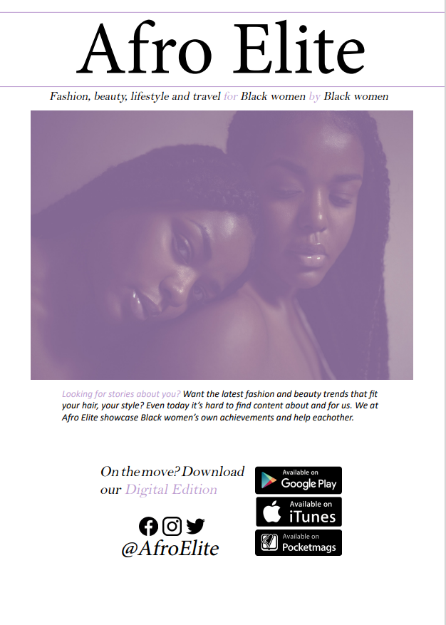
— Afro Elite (final magazine / Afro Elite advert on page 17)
Speaking of advertisements, I found that many luxury magazines advertise luxury products for obvious reasons so I did the same with my magazine. I found a Dior ad in the Billions Luxury Magazine I had and realised how simple the advert was (picture & the brand logo) so I scrapped my previous advert for Dior and changed it so that it was simpler. This was also the reason I changed the Louis Vuitton advert in between the rough draft and the final edit.

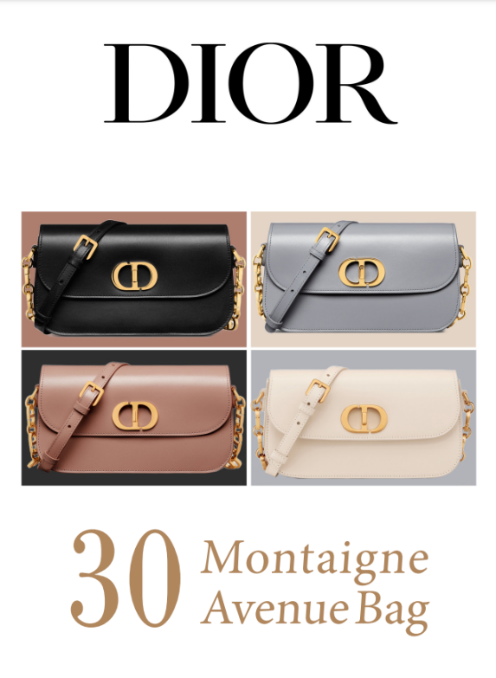
— Afro Elite (04/05 draft of magazine / Dior advert on page 7)
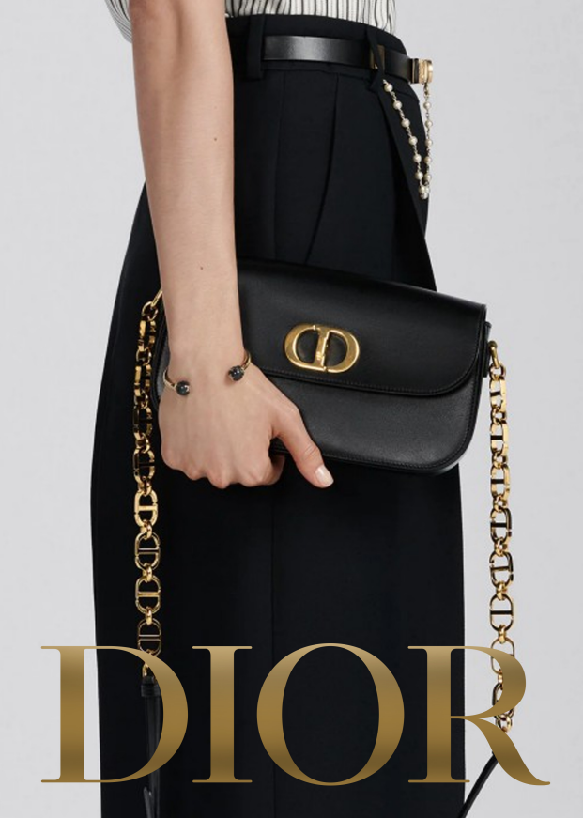
— Afro Elite (final magazine / Dior advert on page 7)
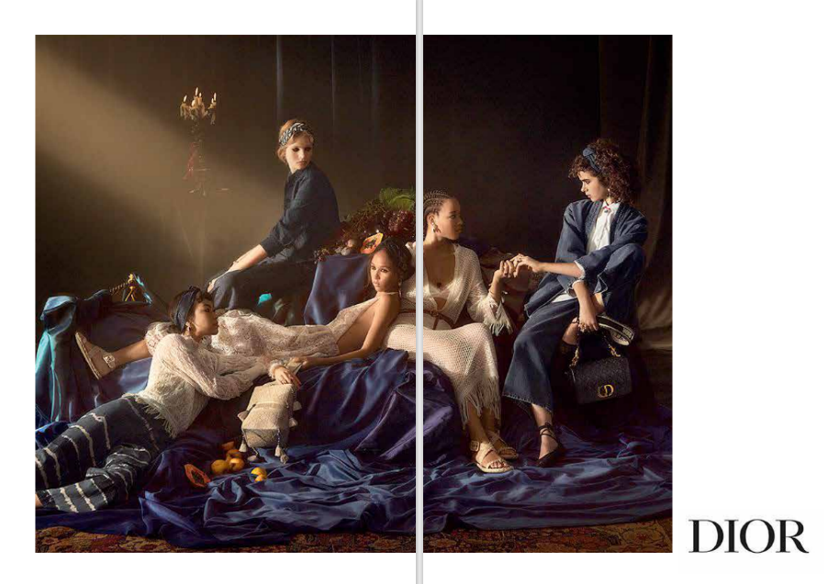
— Billions Luxury Magazine (Dior advert on page 232)
For the front cover I worked with what I already knew about the codes & conventions of fashion magazines (from the Interactive Magazine unit in my first year) and other luxury magazines. I was mainly using Luxury London front covers and the Vogue one down below as references for my own. Afro Elite has a tagline at the bottom that features the other articles featured in the issue like how Luxury London does and both include who’s featured in the issue as a headline, with a very small description of them below. While looking at other luxury magazines, I noticed they didn’t use issue numbers but instead catalogued each issue by the season & year they were published. This can also be seen in my magazine below the masthead.
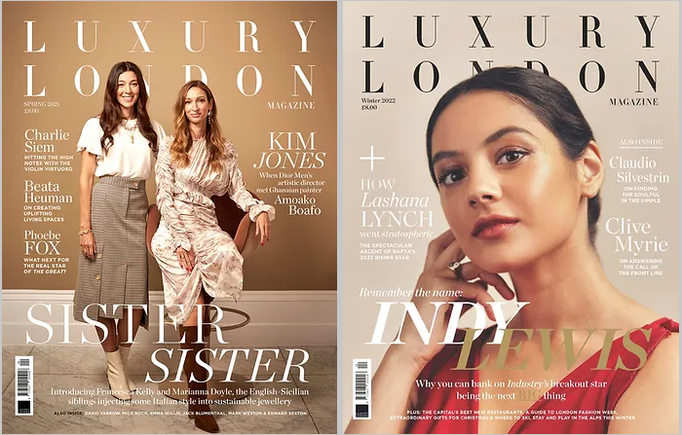
— Luxury London Magazine
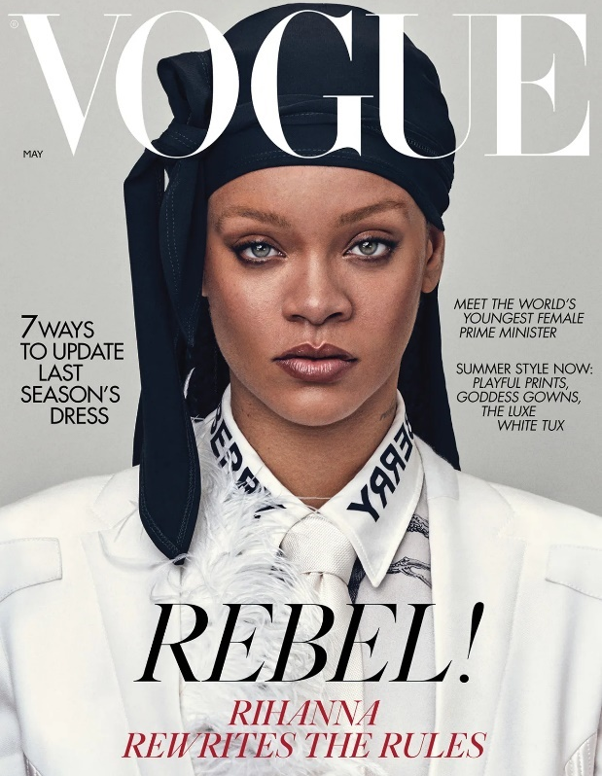
— Vogue Magazine
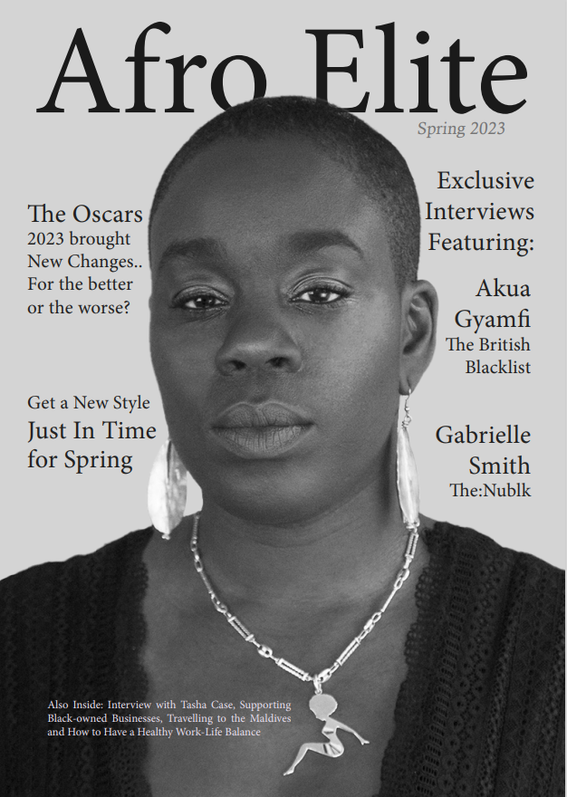
— Afro Elite (final magazine / front cover)
I also added more experimental elements to the magazine so that it’d be more interesting to read and would stand out against other luxury magazines. I experimented with text layout to create the effect seen below. I was mainly inspired by a few images in a Pinterest board made by one of the magazine designers who gave me feedback throughout production. This text layout isn’t completely out of the blue in luxury magazines as Conde Nast Traveller (a luxury travel magazine) also used a similarly experimental design.
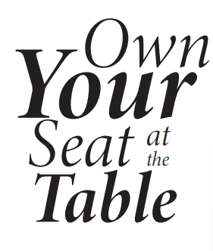
— Afro Elite (final magazine / Interview: Tasha Case on page 20)
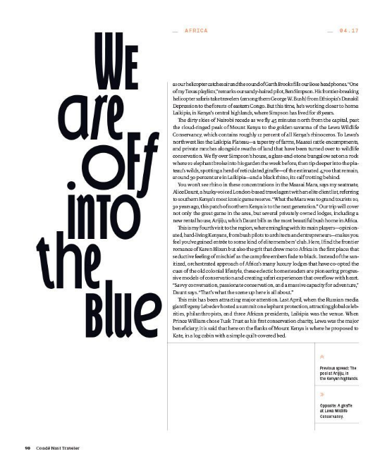
— Conde Nast Traveller
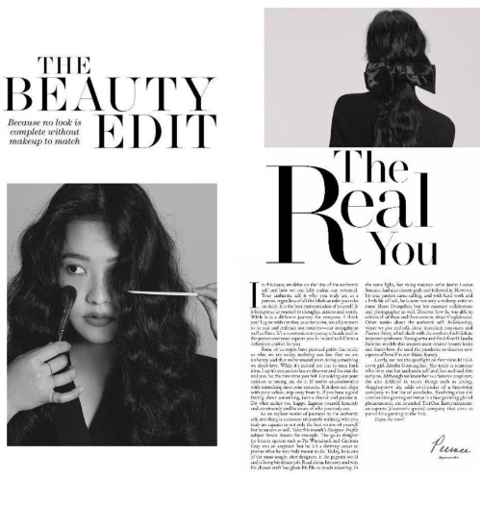 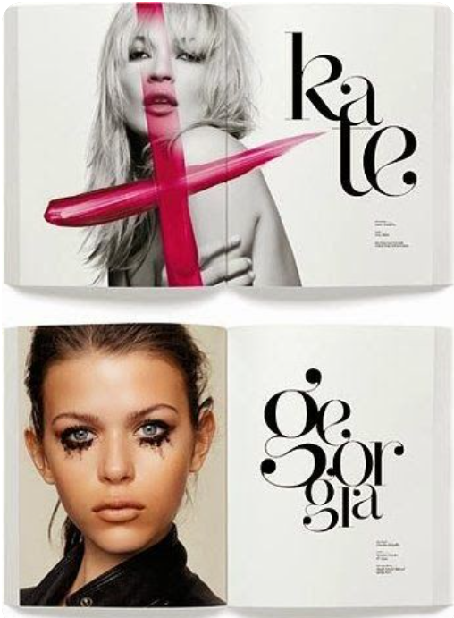
— Pinterest board for D’oro Magazine
I was also experimental when it came to page layouts for the same reason, like with The Oscars 2023 Proves that Times are Changing page. I realised at the time that making a page like this could be divisive since I didn’t see any luxury magazines that were designed like this, but I feel like this design is much more interesting and memorable than the one I was previously using which was a lot plainer. This design also forced me to learn how the pen tool in InDesign works, which was something I was purposely avoiding previously. After using it I understand how to use it a lot more although I wouldn’t call myself advanced with using it still. I was slightly worried that this would make the text harder to read once printed, but it’s actually very easy to follow and read along to.
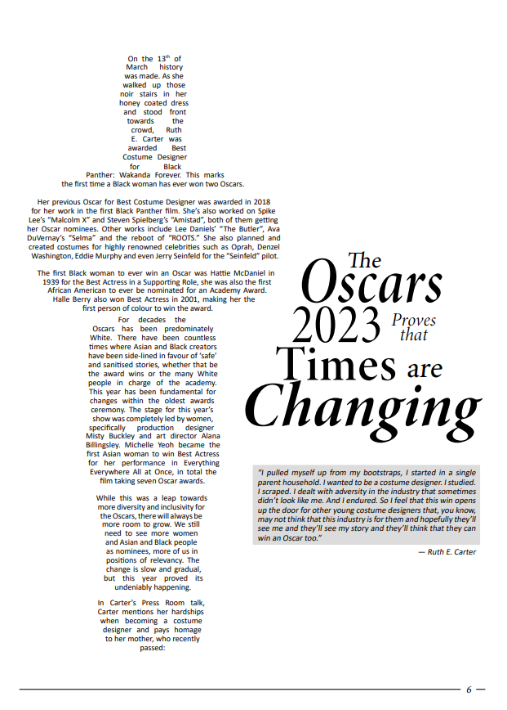
— Afro Elite (final magazine / The Oscars 2023 Proves that Times are Changing on page 6)
I got feedback from one of the copywriters I contacted during research about this article and they said they liked how innovative the page was because of this design choice. While it doesn’t fully fit with what you would expect from a luxury magazine, I’m glad I chose to do this design instead.
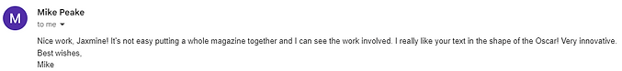
The needs of my target audience have been met as, through my research, I know what the audience would want from a luxury magazine. I mentioned this while talking about the articles, but I catered to the audience by providing them what’s standard in luxury magazines. Majority of the article topics are all topics that are in every luxury magazine (beauty, celebrity news & travel) and includes topics that cater to my target audience specifically, such as many of my articles relating to Black women in some way. The Oscars 2023 Proves that Times are Changing is celebrity news about Ruth Carter being the first Black women to win two Oscars and what that could possibly mean for the future, Hairstyles with a Twist is a beauty article about Black hairstyles specifically and there’s an article about supporting Black-owned businesses. There are also broader articles such as The Top 5 Beauty Products You Need for Spring, Taking a Maldive(s) with The Ritz-Carlton and How To Manage your Work / Life Balance that my secondary & tertiary audience (non-Black people of non-specific genders) can still enjoy as they’re more generalised.
In general Afro Elite is meant to act as a supportive and positive space for Black women, who are my primary target audience, and I think it succeeds in that regard. There are interviews featuring Black women of a similar age range to my primary and secondary audiences (26-30 year olds & 31-40 year olds) that are meant to be uplifting as the last question I ask all of them is “If you could say anything to any aspiring Black women out there, what would you say?”. The Afro Elite advert in the magazine states “Looking for stories about you? (…) Even today it’s hard to find content about and for us. We at Afro Elite showcase Black women’s own achievements and help eachother.” This magazine was always meant to be a celebration of Black women and a space to uplift others and I made that evident in the magazine.
The feedback I got for the magazine all say one thing and that’s that the magazine is designed well. I think this is a great strength of the magazine too, its visually pleasing to look at. While getting audience feedback, one of them mentioned that they liked the colours and layout of the magazine. I mainly colour picked from pictures I was using and also kept the accent colour (light purple) throughout the magazine as its part of the brand’s colour scheme. My favourite pages are the interview ones as I really like the layout I went with for them.
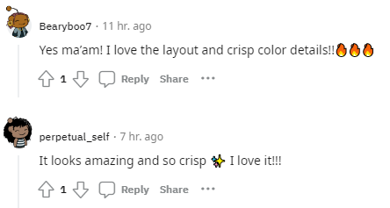
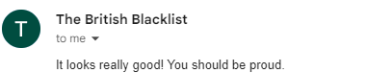
However I think there are still a few problems in the magazine. I think a major mistake I made during post-production was the rush to print the magazine. I didn’t get feedback on the last edit I made of the magazine before sending it to print, even though I still had a week I could’ve worked on the magazine. I originally left out this week so that I’d have time for printing however I think this was more of a detriment to me as it meant I couldn’t make any more changes to the magazine after any criticism.
I sent the final magazine to Tasha Case, one of the contributors of the magazine, and she critiqued her pages saying it wasn’t edited well. At the time I didn’t understand what she meant by this, but now that I reread the interview I understand what she means. I didn’t edit any of the interviews much since it was an interview and I wanted to keep what people actually said, but in the last double spread for Tasha the same phrase is said multiple times. When I was originally typing out the interview I liked the repetition but now that I look back on it I think I should’ve cut some of the repeated phrases out.
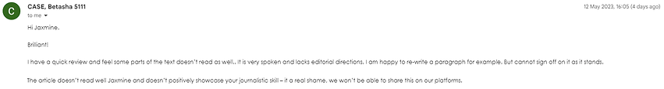
Another issue with the magazine that I haven’t seen anyone point out is that the table of contents is actually wrong. I had to add two more pages to the magazine so that I’d be able to print it and I added it in the middle of the magazine. Everything under "11 ... Taking a Maldive(s) with The Ritz-Carlton" in the table of contents is wrong because of this, which was a sloppy mistake that happened because I rushed so much to print the magazine. I think ultimately giving myself a week for any problems with printing was a good idea on paper, but in actuality a week isn’t needed for this. Only a few days is required and I should’ve made the deadline to print on Monday or Tuesday as it’d maximise the time I'd have to work on the magazine.
The font size in Tasha’s interview is also 1px bigger than the font used in the rest of the magazine & interview pages, which wasn’t something I noticed until the magazine was already printed. I think the font size in general could’ve been smaller and this was a criticism I had against myself during the previous FMP too, but I understand why I didn’t think it was much of an issue at the time as the way I was viewing the magazine in InDesign made it look like the magazine’s font was just fine (I view it on a 75% zoom so that I’m able to see the entire double page spread while editing).
The main thing I learned about my mistakes is that I should really get feedback on the magazine directly before going to print it and that I shouldn’t be in a rush to print either. Getting feedback also includes getting feedback from the contributors in the magazine, even if I wasn’t expecting them to give me feedback on it. The people being interviewed in the magazine are integral to get feedback from too as accidentally portraying someone in a bad light would me a major issue I wouldn’t be able to fix. One of the reasons I didn’t send them how their interviews in the magazine looked is because I wanted it to be a surprise, but that’s foolish of me to do and a dumb reason anyway.
As mentioned before, I think I challenged myself by making this a high-end luxury magazine. I had never made one before but knew I would be able to which is why I stuck with that idea. Controlling my own schedule wasn’t too difficult other than during Easter break for reasons I’ve already mentioned (I don’t work well at home due to distractions and loud noises from my younger siblings, knowing that this was my break also tends to make me lazier when it comes to doing homework. However, knowing that my work would be checked during the break motivated me a lot more to do it and space it out rather than rushing to do all of my work at the end).
I’m not sure if I can say what my most significant moment during this unit, but finally finishing the magazine and sending it off to print (and calling the printers and hearing that there were no errors with the magazine) was a major moment for me. I did enjoy designing the magazine and working with the feedback given by the magazine designers I contacted, the inspiration they both sent me was extremely helpful too, but it felt really nice and freeing to be done with it. I remember looking back at all of my pages before sending it to print and feeling confident in the work I did.
After this unit I’ll be going into university for three years. If all things go well it’ll be the University of the Arts London, which is funny because they’re going to see this. I’ll be creating more and more magazines and learning about them there, which I’m excited about. Hopefully I’ll improve in making magazines and print media in general and Afro Elite won’t be my magnum opus, but for now it is.
But finally, I want to talk about why I chose to do a magazine like this in the first place. I mentioned it during the extra diary I did on Daily Diary 28/04 (production) and my picture is literally in the magazine so this should be obvious, but I am a Black woman myself. The only one in my class in fact. I never really acknowledged it much until a guest speaker came in and was talking about representation in media set in older times and they were asking for volunteers to have a discussion on it, then I looked around and realised I was the only Black woman in the room. It felt shocking and a bit unnerving and that moment has stuck with me since.
I’m not sure how many Black women are working in creative media sectors. I’m sure there are many out there and I’m glad they’re there, as we deserve to be. But I don’t know how many there are and to be honest a lot of that is on me for not looking, but a part of that is because I’ve always viewed creative media (films especially) to be a very White male led field. Once again a part of that really is my fault but when that stigma is there it can be difficult to get any courage to try anything in a space like that.
The reason I made Afro Elite is for a very selfish reason, I wanted to find other Black creatives for myself. I wanted to see if they were truly here. This unit was the motivation for me to force myself to look as I knew if I did it on my off-time I would’ve procrastinated over and over on it until I inevitably forgot. It’s to create a space where Black women support each other and I could support them and imagine this would be how it is if there was more than myself in my class. The reason why the original target audience was so young and I asked other Black women “If you could say anything to any aspiring Black women out there, what would you say?” was because I was making this and asking them that for myself.
I want there to be more spaces like Afro Elite. I want more communities where Black women support each other no matter how successful or famous someone else gets and I want to be a part of that community without feeling anxious to show myself. Communities out there exist already I’m sure and I just got too shy to ever be part of them, but with this magazine I hope that I’ve shed off that anxiousness even a tiny bit. I’ve always come off as an unconfident person despite not being that and that’s a personal issue I’m not sure if I’ll ever solve on my own, but I have to keep trying.
Maybe Afro Elite will only stay as a project I did for my final year in college and I'll continue having three copies of it that I’m unsure what to do with, or maybe it’ll grow into something more. Maybe this isn’t the last time you’ll see Afro Elite. But through and through, this was an extremely personal and important magazine for me. I know I’ll grow up and dislike it like I do with vision and all of my other projects, it has flaws that I’ll definitely see until the end and issues that prevent it from being perfect. But its mine isn’t it? Good God is it mine.

